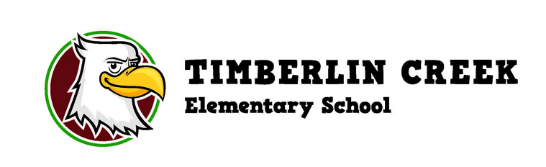
School Advisory Council Meeting Agenda
Monday, April 5, 2021
3:30 PM to 4:30 PM via Teams or Media Center

Thank you for volunteering to serve on TCE’s School Advisory Council. We value your time, opinions, and dedication.

I. 3:30 ~ Welcome – Mrs. Kelley

II. 3:35 March Meeting Minutes [Vote] – Mrs. Matolka

III. 3:40 ~ Battle of the Books/SSYRA and SSYRA Jr. – Mrs. Roberson

IV. 3:55 ~ School Recognition Funds – Mrs. Matolka

V. 4:05 ~ SAC Staff Survey – Mrs. Kelley

VI. 4:10 ~ Request for Proctors for FSA testing – Mrs. Kelley

VII. 4:25 ~ Principal’s Report – Mrs. Edel

VIII. 4:30 ~ Request for SAC co-chairs – Mrs. Matolka

IX. SAC member survey https://surveys.stjohns.k12.fl.us/TakeSurvey.aspx?SurveyID=m6L2l6m1

X. 4:35 ~ Next meeting reminder/Adjourn – Mrs. Kelley

