School Advisory Council Minutes
Monday, March 6, 2023

I. 3:20 ~ Welcome and Introduction– Ms. Moody

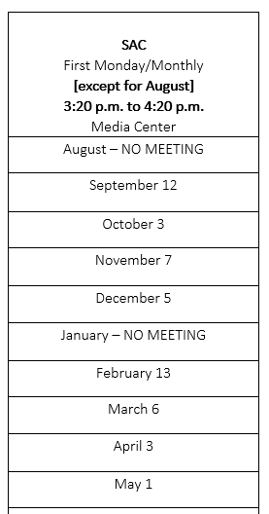
II. 3:35 ~ February Meeting Minutes [Vote] – Ms. Moody

A motion to approve February Minutes was made by Nancy Matolka. It was seconded by Aimmi Straight. The Minutes were approved.

III. 3:40 ~ SAC Funding Request Presentations

4th Grade Ms. Uva presented.
Ms. Uva is requesting 6 sets of LEGO BricQ kits which cost $800. These kits will help to bring math scores up, help to keep students engaged, help with behavior issues and will help with partner learning.

A motion to approve SAC funds for the 6 sets of LEGO BricQ kits for Ms. Uva – 4th grade was made by Tatitha Henderson-Coles. It was seconded by Nichole Errington. The motion was approved.

IV. 3:50 ~ Principal’s Report- Budget, Tutoring & Technology

Field Studies: There is a shortage of bus operators so more teachers are choosing to do in-house field studies. Mrs. Edel commended teachers for the great job they are doing with in-house field studies.

Playground Equipment: Playground equipment on the primary playground and playground equipment on the intermediate playground have been removed. Replacement cost is $62,000 each. TCE has asked District to help, and District has agreed to help us with the purchase of playground equipment for one of those areas.

Villas: We got 4 new villas last year, and we are getting 6 new villas this year. Mrs. Edel plans to move STEAM and INSPIRE to a villa for the upcoming school year which will leave 4 villas for new classrooms.
Mrs. Edel plans to put computer resource back on a cart. Three rooms would then be available to use as computer labs. Ms. Edel would like to use existing laptops that are on carts now for the computer lab.

Tutoring: TCE will receive money from the district for 4th and 5th grade. IRIP (Intensive Reading Initiative Program) 1 teacher to 5 students and Essers Grant with same ratio, 1 teacher to 5 students, for K – 3rd.

Computers: PTO contributed $60,606 for laptops. Laptops were $480 each, so 126 laptops were purchased. Our new TSS/IT, Carlos Trueba, has been preparing and delivering the new laptops. Each classroom, ESE, K-5th, will receive two new laptops. He has delivered laptops so far to the red house (5th grade), dark blue house (ESE/kindergarten), light blue house (kindergarten), orange house (4th grade), and villas 1-8.

V. 3:55 ~ Grade Level Share-Out

Kindergarten and 3rd grade - Field Day
5th grade - LEGO BricQ

VI. 4:00 ~ Adjourn/Next Meeting April 3, 2023

Motion to adjourn made by Anna Montauredes. It was seconded by Carrie Perle. Meeting adjourned.

