School Advisory Council Minutes
Monday, February 13, 2023

I. 3:30 ~ Welcome and Introduction– Ms. Moody and Mrs. Fowler
Everyone introduced themselves and stated their role

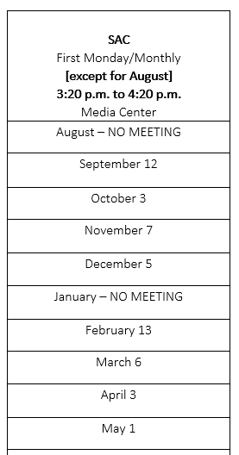
II. 3:35~ December Meeting Minutes [Vote] – Mrs. Fowler

The county notified us recently that we do not need to
send the SAC Needs Assessment Survey out. District
sent out parent/educator/student (3-12 grade) survey
links in the fall as part of the accreditation process.

Update on SAC request for the use of funds:
Libraries were received by kindergarten from St Johns County School District, so SAC funds were not used.
Third grade received testing booklets.
Fifth grade received LEGO BricQ Kits.

A motion to approve December minutes was made by Frank Spinner. It was seconded by Carrie Perle. The minutes were approved.

III. 3:40 ~ Principal’s Report- Budget & Grade Level Tutoring

SAC Funds $8,206.21
School Recognition Funds $1,380.39
~Resource books have been ordered
~Schoolwide tutoring information has been sent home to parents.
~Grants will be used for tutoring instead of SAC Funds.
~Conscious discipline was discussed.
TCE plans to implement a ten-minute morning meeting before NEST
which will focus on social/emotional learning. The meeting will include a
connection activity. It will be a positive way to start the day and will help to
build relationships.
~Discussed purchasing Kagan Cooperative Learning Materials with SAC
funds.

IV. ~ Grade Level Share-Out

~Fifth grade (Ms. Moody) – 4H speeches, dividing fractions, reading & writing.
~Fourth grade (Ms. Perrigo) – Speeches
~Third grade (Ms. Dubet) – Sun/Stars Unit, preparing for FAST test
~Second grade (Ms. Matolka) Immigration Study – Parents will tell their family
story.
~First grade (Ms. Fowler) First grade teamed up with fifth grade for literacy.
They are working on time & money and adding and subtracting 3- digit
numbers. Fundraiser: Collected money for Safe Pet Rescue. There was an
article in the Creekside paper.
~Kindergarten (Ms. Kusiak) They are working on comprehension, building
blocks of story elements (beginning, middle and end), and math – teen
numbers. Students should be fluent up to 20 by the end of the year. Each
kindergarten class will be given a topic for their very own story. Students will
write a page. The story will be published for the class.

V. 4:00 ~ Update on Spending SAC Funds
~Teacher requests for SAC funds are still being accepted.
~We have money for spending.
~We are looking to spend more money on technology in the future.
~The laptops that were purchased by the PTO have been received
~Once our I.T. person arrives, the laptops can be imaged.
~Tech update at March SAC meeting.

VI. 4:15 ~ Adjourn/Meeting Reminder: March 6, 2023

Motion to adjourn made by Dara Dubet. It was seconded by Nancy Matolka. Meeting adjourned

