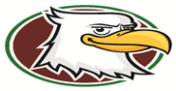
Timberlin Creek Elementary School
2020 - 2021
ESE Grade Supply List

Hard Pencil Case
Crayons (preferably Crayola)
Washable Markers (thick)
Gluesticks
Sharpened Pencils
Roll of Paper Towels
Snack size bags
Gallon size bags

