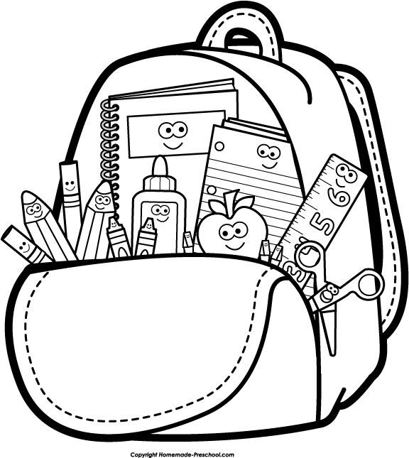
PreK School Supply List 2021-2022

- 1 pencil box for individual school supplies
- 2 packs of 24 Crayola crayons
- 2 packs of Elmer’s glue sticks
- 1 bottle of Elmer’s white glue
- 1 pack of washable markers
- 1 pack of watercolor paint

- Full sized backpack
- 1 spill-proof water bottle
- 1 napping/rest mat (options on Amazon)
- 1 crib sheet & 1 personal (non-oversized) blanket OR bedroll
- 2 changes of clothing
- Diapers/wipes (if needed)

- 2 rolls of paper towels
- 2 boxes of tissues
- 2 containers of hand sanitizer
- 2 bottles of Lysol
- 2 packs of disinfecting wipes
- 1 pack of gallon, sandwich, and quart size Ziplock bags
- 1 pack of dixie cups (5oz)

*Please be sure to label your child’s personal belongings with permanent marker

