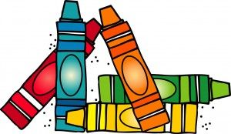 Timberlin Creek Elementary School
Kindergarten Supply List 2022-2023

Markers-Crayola, Washable, Thick, Classic Colors (8 ct.) 1 pack
Glue Stick-Elmer’s (Jumbo size) 6 sticks
Scissors-Fiskars, 5” blunt tip 1 pair
Pencils-No. 2 (sharpened) 2 packs
Crayons-Crayola, 8 ct., primary-traditional colors (not fat) 2 packs
Crayons-Crayola, 24 ct. 2 packs
Composition Book 1 notebook
Spiral Notebook-wide ruled 1 notebook
EXPO brand Dry erase markers (prefer black) 2 packs (1 regular size, 1 thin size)
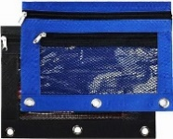
Headphones (no earbuds)
1 Pencil Pouch-any color (as shown, approximately 9” x 7”)
Over-sized t-shirt for art class
Change of Clothes (in Ziploc bag)
Box of tissues
Disinfectant wipes
Baby wipes
1 bottle hand sanitizer with pump or refill size
1 roll of paper towels
2 containers of Play-Doh brand -4 oz. size
1 box band aids
Girls | Boys
Ziploc Bags (Gallon Size) | Ziploc Bags (Sandwich Size)

