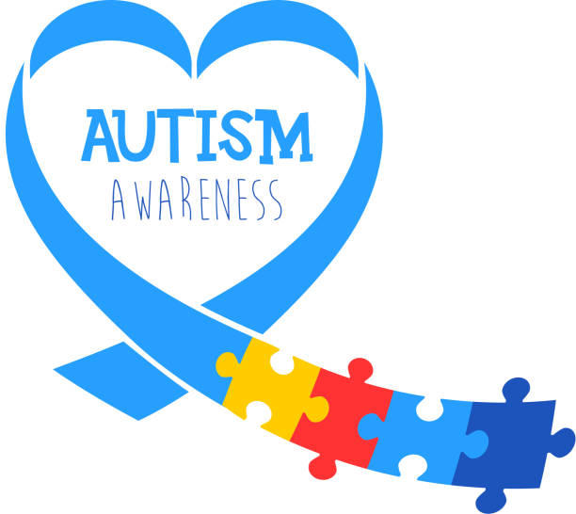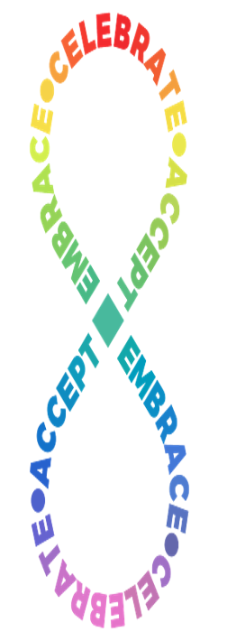

**Monday, April 14th ~Acceptance Rocks our Socks** Wear silly socks to show support and embrace unique differences in others.

**Tuesday, April 15th ~Sensory Friendly Day**

Some people on the autism spectrum have sensory sensitivities. Dress up today in your pajamas or most comfortable clothes.

**Wednesday, April 16th ~ Wonderful World**

There are also many other months that celebrate the wide range of what makes the world wonderful! January: Braille Literacy, February: Epilepsy, & American Heart Month, March: Developmental Disabilities, April, Autism Acceptance, May: Mental Health, October: Down Syndrome Awareness and many more…. Wear colorful clothes to represent that the world is a colorful place!

**Thursday, April 17th ~ Neurodiversity Thursday**

Our brains our unique! To celebrate the beauty and the diverse spectrum of the human minds, wear a tie-dye shirt to school!

**Friday, April 18th ~ What’s Your Passion**

One characteristic of autism is to show incredibly focused passion for topics of interest. What are you passionate about? Dress up to show something you love.

**April 14th- 18th**

**Autism Acceptance**

**Spirit Week**