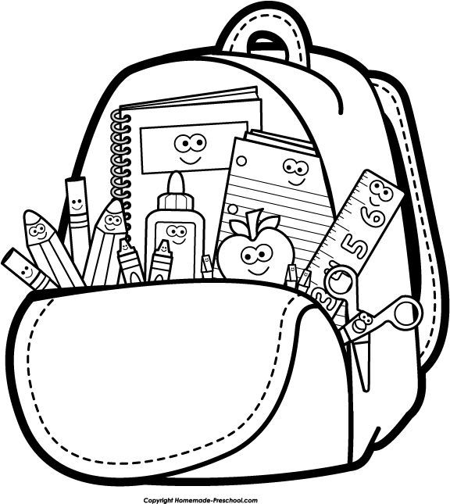
PreK School Supply List 2026-2027
- 2-3 containers of Clorox wipes
- 2 rolls of paper towels
- 1 plastic pencil/crayon box
- 6 Elmer’s glue sticks
- 2 boxes Crayola 16 pack
- 1 bottle Hand Sanitizer
- 1 roll of packaging tape
Ziplocks
- Boys please bring: 1 box gallon size ziplocks
- Girls please bring: 1 box quart size ziplocks
Card Stock
- Boys please bring: 1 ream of Bright White Card Stock
Girls please bring: 1 ream of Colored Card Stock
- Full sized backpack (not the small toddler size)
- 1 spill-proof water bottle
- 1 bedroll for naptime
  - Example on amazon https://www.amazon.com/s?k=child%27s+bedroll&crid=69EAOSM2M2P1&sprefix=child%27s+bedroll%2Caps%2C270&ref=nb_sb_noss_2
- 2 changes of clothing (to be kept at school)
- Diapers/wipes (if needed)
- **Please send in a family picture to add to our class family tree.
*Please be sure to label your child’s personal belongings with permanent marker

Wish List/Optional Requests:
- Magnets – magnet clips, magnet hooks
- Laminating Sheets (8 1/2x11 – 5 mil)
- Astrobright Colored Paper
- Gift Cards for the following places: Amazon, Walmart, Office Depot/Max

